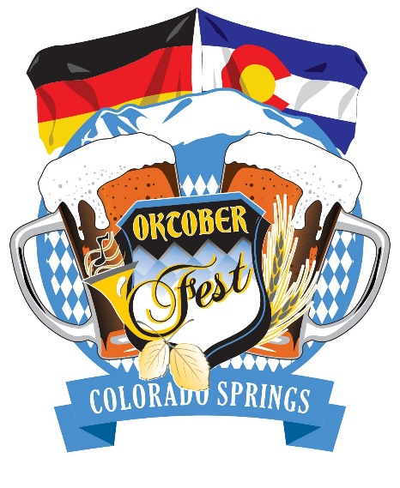
Wilkommen Bei OktoberFest!
Once a year Colorado Springs hosts Germany’s most famous celebration, and we are proud to present the:
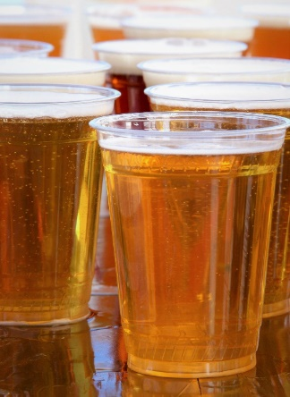
2017 Colorado Springs OktoberFest!
Hosted by Security Service Field
September 22 -24
Admission to the festival is FREE!

Friday 4-11 Saturday 10-11 Sunday 11-8
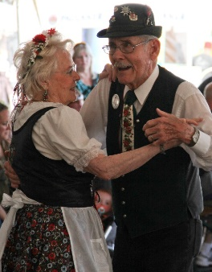
The Colorado Springs OktoberFest is a community event bringing German, Bavarian, and Austrian culture to the Pikes Peak region! The event is open to all ages, with activities for everyone!
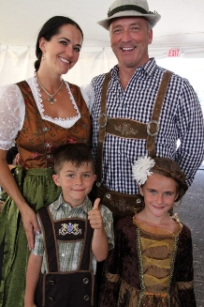
Warsteiner Brewery has brought four of it’s finest beers, all the way from the breathtaking Arnsberg Forest of Germany. Warsteiner Beer has been brewed for centuries, adding true authenticity to the festival and its flavors! And of course, they brought Das Boot with them, which you can purchase, along with our Commemorative Stein, both online at CSOktobeFest.com or at the festival!
It wouldn’t be a festival without competitions! Keg Bowling will test your strength and accuracy, as well as make some noise!Giant Beer Pong is your opportunity to be the first ever OktoberFest Beer Pong Champ. Try our Das Boot Race Relay, the team with the fastest time will each receive their very own Das Boot from Warsteiner Beer! Participants are encouraged to preregister online at CSOktoberfest.com! On the main stage we will also have Stein Hoisting, “Mein Stein”, and Costume contests! Winners of the stage contests will receive a beer from Warnsteiner Beer. Those who like to people-watch can enjoy the music and dancing, provided by The Primetime Band, U-Turn Brass, and the Denver Kickers. For the best costumes, OktoberFest attendees should go to local favorite Zeezo’s, right downtown or online.
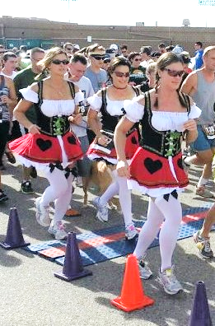
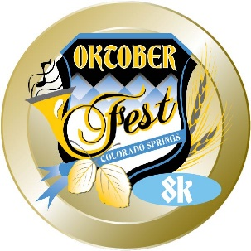
Our largest OktoberFestivity is the Grand Prix of Running’s OktoberFest 8k. Beginning and ending by the gates of Security Service Field, runners can look forward to a cold Warsteiner beer and a commemorative stein to put it in after they run their race. Winners overall, and of each age division will receive awards. We will also be honoring our best dressed runners on the stage in the Main Hall Beer Tent! Viel Erfol!
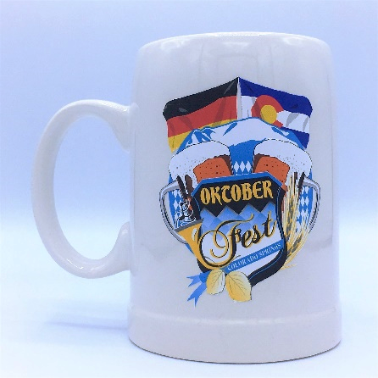
For our younger attendees, we will have our very own Die KinderZone. Once admitted the kids can play on different jump houses, make their own German pretzels, and get their face painted. They can also learn about German culture and language.
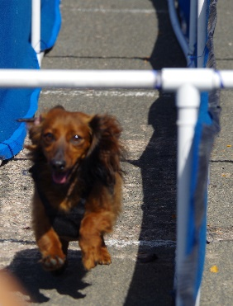
In true OktoberFest fashion we present our furriest attraction: The Dachshund Dash! Conducted Saturday and Sunday afternoon, our only four-legged friends allowed into the OktoberFest will compete in age groups until the fastest wiener wins! All pups are encouraged to get dressed up, with the best dressed pup for each day will be awarded!
Germany is known for its fine wines and unique food, and this year in cooperation with Schnitzel Fritz German Restaurant and Deli, and Cheers! Liquor Mart we would like to present our OktoberFest Experience Packages:
  - Cheers! Liquor Mart presents the German Vineyard Wine Tour, an experience that allows participants to learn about the wine they are drinking. Both sessions and seatings are limited.
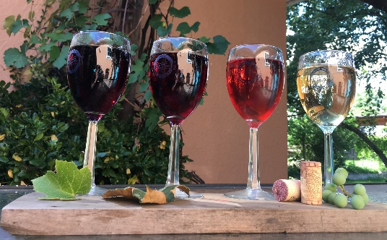
  - The art of German cuisine will be brought right to your tastebuds thanks to Schnitzel Fritz, proud hosts of the BrewMaster’s Dinner. A five course meal as close to being in Bavaria without taking a plane. The meal is sure to please and if you are thirsty you can upgrade your experience by adding our BrewMaster’s hand selected drink pairings, provided by Cheers! Liquor Mart.
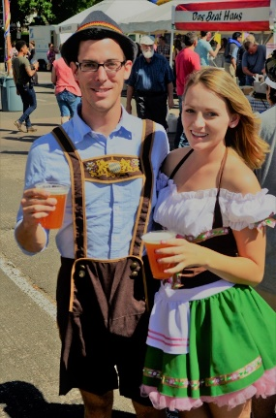
  - Sunday only, guests can look forward to a traditional German Brunch hosted by Schnitzel Fritz. Fine breads, cheeses and wine will be served fresh. The most delicous and savory brunch food will be served alongside traditional German Aperitifs and other livations.
  - This year we are offering a multitude of Beer Stein Packages. This includes our Big Das Boot package, which does contain a 2 litre Das Boot beer stein as well as beer and cocktail tokens. Collectors of our cmmemorative stein can purchase our Commemorative Stein packages but to get the best deal you have to purchase online at CSOktoberFest.com

More information, including a detailed event schedule will follow! For any further question fill free to call Kaleigh O’Donnell at (719)635-8803.

